Who Pays for Singapore's Green Premium?
CN4252 Midterm Reflection by Wee Zhern Ray
Background and Context
Singapore relies on imported natural gas for about 95% of its electricity [1], and we import most of our energy needs [2]. Since independence in 1965, we have never had natural resources to fall back on. There is no fossil fuel under our land, so we have never been able to produce our own fuel. Even our refineries depend on imported crude, about two thirds of which comes from the Middle East [3].
This leaves Singapore vulnerable whenever the world is under stress. When energy prices spiked after the war in Ukraine [2], and again when the conflict in the Middle East effectively closed the Strait of Hormuz in 2026 [3], it left every country protecting their own self interests. We all understand that when supply is tight, sharing becomes strenuous. This is why Singapore has been looking harder at renewable energy systems, and why hydrogen has become a key part of the conversation, mainly because it is sustainable in the long term and easy to scale up.
I began to learn more about hydrogen technologies through my Specialisation in Safety and Sustainability and my Minor in Hydrogen and Low Carbon Technology. This led me to take CN4252 Hydrogen and Low Carbon Technologies, Industry Perspectives, where we hear from a leader in a different field every week. These talks gave us a cascade of perspectives on hydrogen and low carbon technologies in Singapore and around the world. In this reflection, I draw mainly on four of them, namely Dr Mei Chia of Aether Fuels, Mr Lau Wei Jie of the Global Centre for Maritime Decarbonisation (GCMD), Dr Lim Kang Hui of CRecTech and Dr Ayako Kameda of Obayashi Corporation. Together, they changed the way I think about a policy that will now affect every plane ticket I buy.
The levy on every plane ticket
On 18 August 2026, Dr Mei Chia gave a lecture on her company and its core product, sustainable aviation fuel (SAF). She shared that tickets sold from 1 October 2026, for flights leaving Singapore from 1 January 2027, will carry a levy of S$1 to S$41.60, depending on distance and cabin class [4], [5]. Frankly, I reacted like any other Singaporean and complained about the increase in price. As a consumer, I naturally lament when the things I buy become more expensive.
Dr Chia added that the levy will be pooled into a fund run by a new government owned company, the Singapore Sustainable Aviation Fuel Company (SAFCo), which will buy SAF to make up 1% of the jet fuel used at our airports, rising to 3 to 5% by 2030 [6]. The levy is backed by a 2025 amendment to the law governing the Civil Aviation Authority of Singapore (CAAS), which Parliament passed in October 2025 [7]. It is Singapore's approach to sustainable aviation, and part of a bigger plan towards net zero emissions from international aviation by 2050 [4], [8].
The more I thought about the extra premium, the more annoyed I became. Every time I flew, I would now be paying more for exactly the same service. So, as a concerned Singaporean, I asked Dr Chia whether private jets and business aircraft would be charged too. She said she was not sure. When I checked later, I found that the levy does apply to private and business aviation flights, and to every passenger who starts their journey in Singapore. Transit passengers are exempt, and cargo has been deferred by another year, so it is not quite every aircraft, but it is much wider than I expected [4], [5].
So how do we know that the price of the levy is fair?
That was the question I kept pondering. After doing some research, my view is that the SAF levy is a market formation fee. Singaporean travellers pay to build an industry and protect a hub, while the emission reductions they fund are claimed by airlines and companies. If those companies are Singaporean, I would be more comfortable paying the extra fee, because we would be taking responsibility for our own national aviation hub. But if they are multinational companies that serve the global industry, or even prioritise other countries, is it fair for Singaporeans to pay for a cause that is not only ours? In my view, the levy can only be fair if every stakeholder can see what they get in return, and the policy is published clearly. I will come back to what this could look like at the end of this reflection.
Why the green premium exists, and how SAF is produced
Dr Chia explained that aviation is one of the hardest sectors to decarbonise, because there is no easy substitute for liquid jet fuel. Jet fuel packs about 43 megajoules (MJ) of energy into every kilogram, and batteries come nowhere close on energy per kilogram. Hydrogen is also a poor fit, because it needs heavy and bulky tanks that are either pressurised or cryogenic, which raises serious safety and design concerns on an aircraft.
SAF gets around this problem because it is chemically almost the same as conventional jet fuel. The main difference is that it is produced sustainably, through alternative routes approved under the ASTM D7566 standard, set by ASTM International (formerly the American Society for Testing and Materials) [9]. This allows SAF to replace traditional jet fuel in today's engines and pipelines without modification. The catch is the price. Dr Chia told us that SAF trades at roughly 2 to 2.5 times the price of conventional jet fuel, and the International Air Transport Association (IATA) likewise describes it as several times more expensive, even though it can cut lifecycle carbon dioxide (CO₂) emissions by around 80% [10]. The most common route today is HEFA, short for hydroprocessed esters and fatty acids, which turns used cooking oil and waste fats into jet fuel [10]. These feedstocks are limited and in high demand, and every batch of SAF must pass third party testing and certification before it can be sold. Aether Fuels takes a different route. Its Project Beacon, built with Aster on Pulau Bukom, plans to convert industrial waste gas and biomethane into SAF [11].
She also explained that buyers only accept the premium because sustainability certification lets them claim the emission reduction. The claim is what they are really paying for. This stayed in my mind, because it raised the next question. When Singaporeans pay the levy, who actually gets the claim?
Shipping faces the same question
Two weeks later, on 1 September 2026, Mr Lau Wei Jie of GCMD spoke about decarbonising shipping, another sector that is very hard to abate. He explained that Singapore is looking to use ammonia instead of natural gas for some of our power. Ammonia is a cheaper and more available way to bring hydrogen to us, because it is a hydrogen carrier with established supply chains [12]. His point was that, taken overall, ammonia is comparable to other fuels for generating electricity while also being sustainable. That comes with a caveat, because the challenges are real. Ammonia contains no carbon, so burning it releases no carbon dioxide [13]. However, it is corrosive, which puts pressure on equipment and maintenance, and burning it can still release nitrogen oxides (NOx) and nitrous oxide (N₂O) [14]. NOx harms air quality, while N₂O is a greenhouse gas 273 times as potent as carbon dioxide over 100 years [15]. How clean ammonia is also depends on how it is made, because ammonia made from natural gas is only low carbon if the carbon dioxide from producing the hydrogen is captured, while ammonia made with renewable electricity avoids that problem [13]. Ammonia bunkering, which means refuelling ships with ammonia, is also meant to replace marine diesel, which is already a big step forward for such a hard to abate fuel. What stood out to me is the timeline, as he said implementation is targeted for 2030, which is very soon. That is ambitious, because the Keppel led project on Jurong Island plans to burn ammonia directly in a gas turbine, so the combustion challenges above still have to be solved at scale [12].
But the same accounting rule applies here. Under international accounting rules, emissions from international shipping, like those from international flights, are reported separately and left out of national totals, so green fuel sold to ships at our port does not reduce Singapore's own national emissions [16]. GCMD has studied how ammonia can be bunkered safely in Singapore, so this is not a distant problem for us [17]. It made me wonder who benefits when a country pays for a fuel whose emissions it cannot count.
Is it fair that Singaporeans pay for the SAF levy?
Two weeks after that, on 15 September 2026, Dr Lim Kang Hui spoke about his journey from the lab to the market. He studied Chemical Engineering at the National University of Singapore (NUS), went on to complete his PhD there, and built his startup CRecTech with support from the NUS Graduate Research Innovation Programme (GRIP) [18], [19]. His startup began with a catalyst developed for steam methane reforming, and only when he went to the market with a minimum viable product did customer feedback push him towards turning palm oil waste into bio methanol for shipping. He has since been named to the Forbes 30 Under 30 list, and CRecTech is backed by Breakthrough Energy, the climate investment network started by Bill Gates [18]. Dr Lim shared an insight from Bill Gates that he will only back technologies whose green premium can reach zero. The green premium is the extra cost of choosing a clean option over a fossil one, so a green technology can only truly compete once that extra cost is close to zero [20].
This is where carbon accounting comes in, and I had to read up on it because I did not fully understand it at first. Under the Carbon Offsetting and Reduction Scheme for International Aviation (CORSIA), a global scheme run by the International Civil Aviation Organization (ICAO), airlines must offset the growth in emissions from their international flights above a baseline, either by buying eligible carbon credits or by using eligible fuels such as SAF [21]. This is different from Singapore's carbon tax, which only applies to facilities that directly emit at least 25,000 tonnes of greenhouse gases a year [22]. So SAF is not a way of paying the carbon tax, as I first thought. It is a way for airlines to meet their CORSIA obligations, and for companies to cut the footprint of their own business travel. This is why SAFCo allocates the Scope 1 claims to airlines in proportion to what each of them contributes to the levy [4].
The caveat is that these claims do not help Singapore's own carbon footprint. As with shipping, emissions from international flights are reported separately and left out of the national total [16]. So when Singapore Airlines (SIA) uses more SAF, our national emissions do not fall.
I asked Dr Lim the question that had been lingering in my mind.
If SAF does not reduce Singapore's emissions, why are Singaporeans paying for it?
He said that many Singaporeans are misinformed on this point. SIA is still Singapore's national airline, and climate change is a global problem that needs global cooperation. He added that Singapore's decarbonisation research grants have rarely funded SAF, precisely because it does not count towards the national target. He reiterated his stand that we, as Singaporeans, should play our part as global citizens.
For one, I agree that we should play our part in decarbonisation. However, I do not agree with the lack of transparency about how our contribution is used. Even if Singapore plays its part, how can we ensure that the other countries do the same? The energy crises showed that countries protect their own self interests when supply is tight, and sharing the burden becomes strenuous. Nepal suffered deadly floods in August 2026 after a glacial collapse, even though it contributes less than 0.1% of global emissions [23]. The largest emitters, such as China and the United States, are not the ones facing the worst of these consequences. So how do we ensure accountability? I did not have an answer, and I still do not.
Six stakeholders at every decision
Dr Ayako Kameda's lecture on 8 September 2026, a week before Dr Lim's, gave me a way to develop my thoughts on that question. After a quick introduction to her company, she split the whole class into six stakeholders, namely (1) Project Development, (2) Finance and Investment, (3) Prospective Customer, (4) Government and Policy, (5) Sustainability and Engineering, and (6) the Board of Directors (Figure 1). The case study was whether a hydrogen refuelling station that had already invested S$5 million in City A should move to City B, where customers seemed more accepting of the technology.
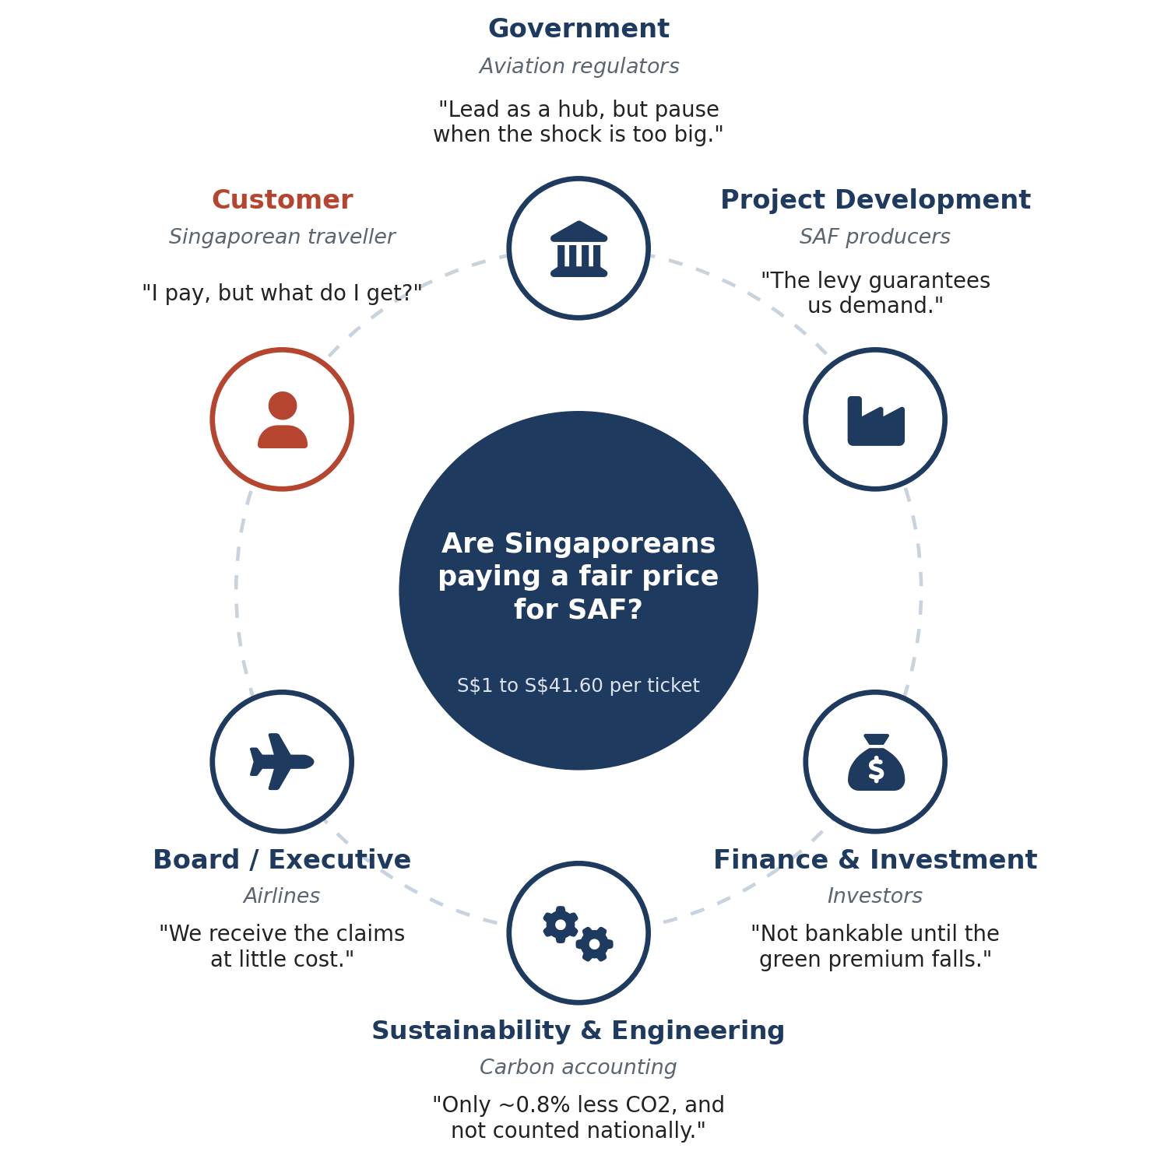
Figure 1. Analysis of the SAF levy through six stakeholders' lenses. Roles adapted from Dr Kameda's case study role play.
Representing the government, I proposed that the company pause the relocation first, to reassess its plan and conduct more detailed market research. Since we would be dealing with the public, safety also had to be examined carefully. I also proposed a one year pilot in a smaller segment of City A, together with subsidies at the early stage of the technology. When Finance asked me why they should stay at all, my honest answer was that we cannot force them. We can only appeal through subsidies, a pilot programme and continued partnership.
Other stakeholders, like the Board, were indecisive and kept promising a techno economic analysis. If it makes money, we stay, and if not, we move. But at that point, do you really have the time to produce a credible analysis? Most of the class wanted to play it safe and hold on, but this was a business decision. Every second spent staying put costs money, so even not deciding is a decision.
At the end, Dr Kameda shared what happened in the real case, in which the company relocated to City B. The call was made on the future potential of the technology, and she made it herself even though part of her team advised against it, as she did not want to tunnel vision and wanted to look at the big picture.
Later that day, after doing some research, I realised that CAAS was facing a similar decision. Like Dr Kameda, it was weighing the future potential of a technology against short term costs. On 25 March 2026, it announced a pragmatic pause, moving the start of ticket sales covered by the levy from 1 April to 1 October 2026, citing the impact of the conflict in the Middle East on airlines and passengers [24]. CAAS chose to delay the levy without dropping it, which is also a call made on the big picture. That role play reframed the levy for me. It is Singapore's bet that industry will stay here and build here, and Singaporeans are the ones paying for it.
Once I had sat in one of those seats, I started looking at the levy from the point of view of all six stakeholders.
Analysis of whether Singaporeans are paying a fair price for SAF
Start with the Customer, the Singaporean traveller. They pay between S$1 and S$41.60 and get nothing they can claim, because the claims go elsewhere. SAFCo allocates the Scope 1 claims to airlines, in proportion to their levy contributions, to help them meet their CORSIA obligations. SAFCo manages the Scope 3 claims centrally, along with any Scope 1 claims that airlines do not take up, and makes them available to organisations that want to cut the emissions from business travel and air freight [4]. And the reduction itself does not count toward Singapore's national target.
Government is looking towards more sustainable energy sources in the long term, which brings hub status, fuel security and a new industry. Dr Lim made the hub argument himself for shipping. Green methanol today comes mainly from Europe and China, so ships simply refuel there, and a hub that cannot supply green fuel risks losing its traffic. The same logic applies to aviation, where Neste's refinery in Tuas can produce up to one million tonnes of SAF a year, about nineteen times the roughly 53,000 tonnes that our 1% target needs, based on Singapore's 2019 jet fuel demand of 5.3 million tonnes [6], [25], [26]. By comparison, Project Beacon on Pulau Bukom will begin commercial operations in 2028 but produce only about 1,600 tonnes of SAF a year, which is around 3% of that target [11]. When Dr Chia was asked why Aether chose Singapore, her answer was strong government support and a levy that is actually being rolled out. But Dr Kameda's slide carried a caveat I keep coming back to, that subsidy can mask weak fundamentals.
Project Development, meaning the SAF producers, gain directly. The levy turns uncertain demand into pooled and predictable demand, which is exactly what a new industry needs.
Finance and Investment would look at the green premium and honestly wince. Using Dr Chia's price range, my own rough estimate is that SAF cuts CO₂ at about S$320 to S$470 per tonne. This estimate comes with caveats, because it assumes jet fuel at about S$800 per tonne, SAF at 2 to 2.5 times that price, an 80% cut in lifecycle emissions and about 3.16 tonnes of CO₂ released per tonne of fuel burned. That is seven to ten times today's carbon tax of S$45 per tonne, and still four to nine times the S$50 to S$80 per tonne that the government aims for by 2030 [22]. Dr Lim stressed that a green technology has to be cheap enough to be implementable, and that one many times above the carbon price is unlikely to become competitive within 10 to 15 years. By his test of being bankable without incentives, SAF fails today.
Sustainability and Engineering would point out how small the effect is. A 1% blend with an 80% lifecycle reduction cuts the emissions of departing flights by only about 0.8% [10]. It is a step in the right direction, but the impact will not be visible now, hopefully in the near future.
Lastly, the Board, which here means the airlines, receives the Scope 1 claims for their own compliance, while the cost of those claims passes straight through to passengers. This means the airlines gain the most benefit, because customers are paying for their green premium directly.
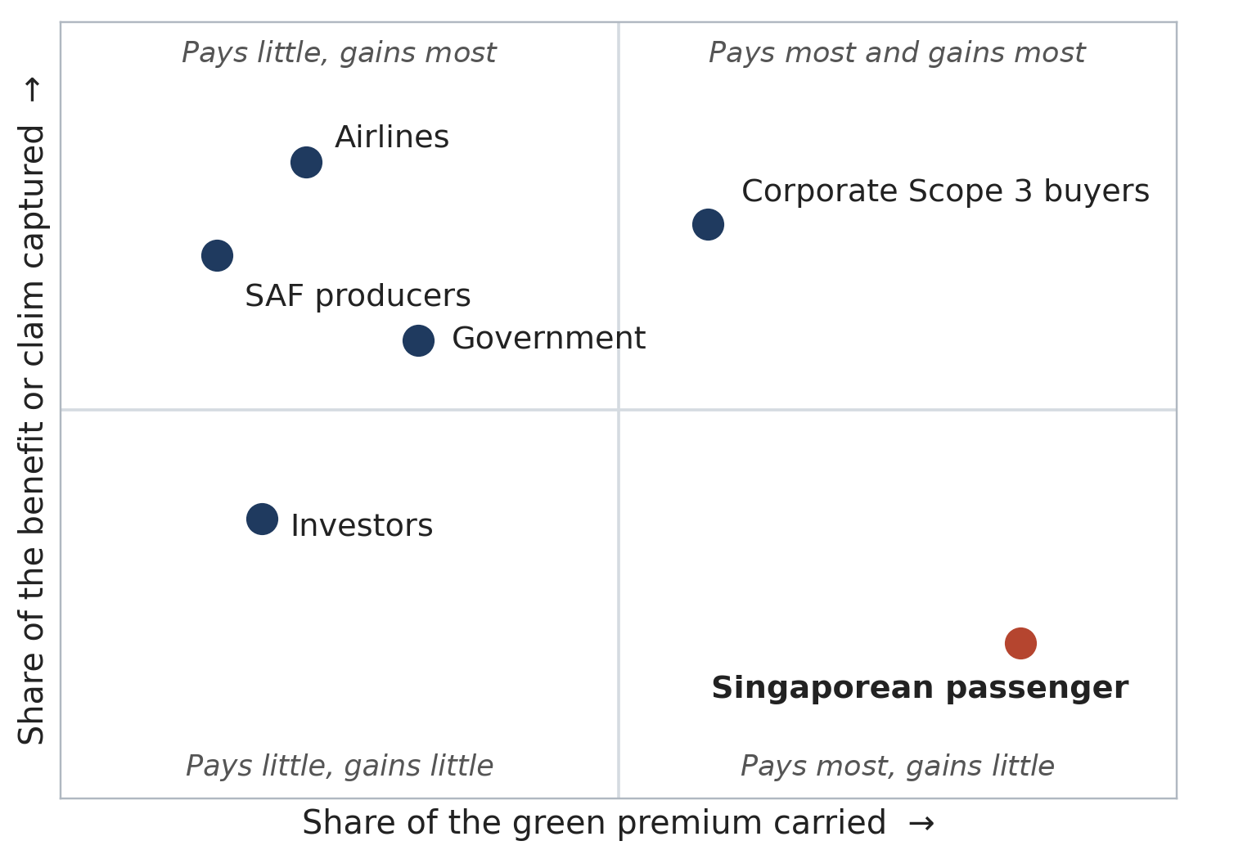
Figure 2. Who pays and who benefits from the SAF levy.
Figure 2 analyses who loses and who benefits from the SAF levy. The Singaporean passenger sits at the bottom right, meaning that they pay the most and gain the least benefit.
If Singaporeans are the ones who pay for the levy, they should also stand to gain from it.
Looking back, aviation, shipping and hydrogen refuelling seem like three different industries, yet the four lectures kept pointing to the same pattern. The technology usually works, but what decides whether it succeeds is who pays the green premium until scale brings it down, and who gets to claim the benefit. Dr Chia introduced me to this problem statement, Mr Lau showed me that maritime shipping faces the same problem as aviation, Dr Lim gave me an informed perspective from someone building in the field, and Dr Kameda invited me to think through different lenses and to make decisions under uncertainty. At the start, I saw the levy as one more charge on my ticket. Now I see it as a question of who shares the burden and who gets to claim the benefit.
Transparency on the levy and Singaporeans' contribution to the green economy
To be clear, I am not against the levy. Singapore cannot be a global hub and opt out of global sustainability costs, and Dr Lim is right that somebody has to move first. If we waited for SAF to reach a zero green premium on its own, we would be the Board in Dr Kameda's case, and doing nothing would still be a decision. So my stand is to keep paying, with one caveat. The levy must be far more transparent, so that Singaporeans can see how their contribution supports the green economy. Sharing a cost becomes strenuous when people cannot see where it goes, and transparency is what makes the burden easier to share. This is the same test I set earlier, that the levy is only fair if every stakeholder can see what they get in return. Sitting in the Government seat, I would make four changes, and each one is about letting people see where their money goes, who benefits and what happens if the plan does not work.
- Show people what they bought. Airlines must already show the levy as a separate line item in the fare breakdown [4]. This should appear on any ticket they buy, so that no passenger has to go looking for it. It should also state how much was paid and how many kilograms of CO₂ it avoids, and SAFCo should publish each year how much SAF it bought, because people accept costs they can see.
- Show who claims the benefit. Business and first class passengers already pay four times the economy rate, which is a good start, but the gap could be wider, because economy passengers mostly fly for family or study [5]. The same logic should reach the airlines and companies that capture the claims, and SAFCo should publish who receives them, so that the burden and the claim can be matched.
- Show that the value stays in Singapore. SAFCo should sign long term contracts with local producers such as Neste in Tuas and Aether's Project Beacon on Bukom. Then the levy grows local jobs, skills and fuel security, and even if the tonnes do not count nationally, Singapore still feels the benefit.
- Have a plan for what happens if we fall short. The step from 1% to 3 to 5% in 2030 should depend on the green premium actually falling. If it does not, there should be a public review that decides whether to adjust the levy, slow down the targets or change the approach, instead of simply carrying on. Dr Kameda's slide put it plainly, that there should be no recommendation without a defined next decision.
In practice, that means a public report when the levy starts in 2027, a first review in 2028, and a 2030 decision made against a published cost target rather than hope.
Future aspirations
The questions from these lectures will follow me. I hope to pursue a master's in chemical or nuclear engineering and build a career in sustainable energy, where first of a kind projects such as advanced reactors will face the same questions about cost, demand and risk. Dr Kameda ended her lecture with a line I keep thinking about. The future needs more than hydrogen experts. It needs people who can understand the science, question assumptions, build viable projects and make responsible decisions. Engineers are not only the people who make the product. They design it, so they must think about all these factors from start to end, or the product is quite useless. I want to be one of those engineers. These lectures kept my mind turning long after each session ended, and I am grateful to Prof Yan Ning for bringing these speakers to us.
If all goes to plan, I will soon be booking a flight to Switzerland for ETH Zurich, or to the United States for schools such as MIT, UC Berkeley or any of the Ivy League schools, where I will be applying for my master's. A flight to the United States sits in the highest band of the levy, at S$10.40 for economy and S$41.60 for business and first class, while Europe, including Switzerland, sits one band lower, at S$6.40 and S$25.60 [5].
Hopefully, somewhere in the fare breakdown, there will be a line for the SAF levy, and I will pay it.
Word count (excluding references and figure captions): 3,993
References
[1] Energy Market Authority, "Natural gas," last updated Dec. 24, 2025. Accessed: Oct. 4, 2026. [Online]. Available: https://www.ema.gov.sg/our-energy-story/energy-supply/natural-gas
[2] TODAY, "Ukraine-Russia conflict will 'significantly' affect energy costs in Singapore, says minister," Malay Mail, Mar. 1, 2022. Accessed: Oct. 4, 2026. [Online]. Available: https://www.malaymail.com/news/singapore/2022/03/01/ukraine-russia-conflict-will-significantly-affect-energy-costs-in-singapore/2044654
[3] D. Dingwall, "Singapore's major oil source is blocked and experts warn Australians will pay," ABC News, Apr. 2, 2026. Accessed: Oct. 4, 2026. [Online]. Available: https://www.abc.net.au/news/2026-04-02/singapore-oil-refineries-energy-shock-response/106504438
[4] Civil Aviation Authority of Singapore, "CAAS to start Sustainable Aviation Fuel Levy for origin-destination passengers, general and business aviation flights from 1 October 2026 for flights departing from 1 January 2027," Press release, Sep. 3, 2026. Accessed: Oct. 4, 2026. [Online]. Available: https://www.caas.gov.sg/resources/media-and-publication/newsroom/caas-to-start-sustainable-aviation-fuel-levy-for-origin-destination-passengers-from-1-october-2026-for-flights-departing-from-1-january-2027/
[5] G. Lim, "SAF levy of S$1 to S$41.60 applies to air tickets bought from 1 October," Little Big Red Dot, Sep. 30, 2026. Accessed: Oct. 4, 2026. [Online]. Available: https://littlebigreddot.com/sustainable-aviation-fuel-levy-air-tickets-from-1-october-2026/
[6] OFI Magazine, "Singapore sets 1% SAF target from 2026," Mar. 8, 2024. Accessed: Oct. 4, 2026. [Online]. Available: https://www.ofimagazine.com/news/singapore-sets-1-saf-target-from-2026
[7] A. Chan, S. Subramaniam, and J. Tay, "Singapore's new sustainable aviation fuel levy and fund, and their implications for airlines, banks, and lessors," Allen & Gledhill, Jan. 2, 2026. Accessed: Oct. 4, 2026. [Online]. Available: https://www.allenandgledhill.com/sg/perspectives/articles/31891/sgkh-s-new-sustainable-aviation-fuel-levy-and-fund-and-their-implications-for-airlines-banks-and-lessors
[8] G. Mok, "Singapore introduces world's first mandatory sustainable aviation fuel levy for departing flights," Seneca ESG, Nov. 20, 2025. Accessed: Oct. 4, 2026. [Online]. Available: https://senecaesg.com/insights/singapore-introduces-worlds-first-mandatory-sustainable-aviation-fuel-levy-for-departing-flights/
[9] ASTM International, "Standard specification for aviation turbine fuel containing synthesized hydrocarbons," ASTM D7566. Accessed: Oct. 4, 2026. [Online]. Available: https://www.astm.org/Standards/D7566.htm
[10] International Air Transport Association, "Sustainable aviation fuel (SAF)." Accessed: Oct. 4, 2026. [Online]. Available: https://www.iata.org/en/programs/sustainability/sustainable-aviation-fuel-saf/
[11] Economic Development Board, "Singapore's Pulau Bukom to house new sustainable aviation fuel plant by Aster, Aether Fuels," Nov. 11, 2025. Accessed: Oct. 4, 2026. [Online]. Available: https://www.edb.gov.sg/en/business-insights/insights/singapores-pulau-bukom-to-house-new-sustainable-aviation-fuel-plant-by-aster-aether-fuels.html
[12] Energy Market Authority, "Consortium appointed for next phase of study on low- or zero-carbon ammonia power generation and bunkering solution," Press release, Oct. 3, 2025. Accessed: Oct. 4, 2026. [Online]. Available: https://www.ema.gov.sg/news-events/news/media-releases/2025/consortium-appointed-to-conduct-next-phase-of-ammonia-power-generation-bunkering-solution
[13] The Royal Society, "Ammonia: Zero-carbon fertiliser, fuel and energy store," Policy briefing, 2020. Accessed: Oct. 4, 2026. [Online]. Available: https://royalsociety.org/news-resources/projects/low-carbon-energy-programme/green-ammonia/
[14] E. F. Eyisse, E. Nadimi, and D. Wu, "Ammonia combustion: Internal combustion engines and gas turbines," Energies, vol. 18, no. 1, Art. no. 29, 2025, doi: 10.3390/en18010029.
[15] U.S. Environmental Protection Agency, "Understanding global warming potentials," last updated Dec. 29, 2025. Accessed: Oct. 4, 2026. [Online]. Available: https://www.epa.gov/ghgemissions/understanding-global-warming-potentials
[16] UNFCCC, "Emissions from fuels used for international aviation and maritime transport." Accessed: Oct. 4, 2026. [Online]. Available: https://unfccc.int/topics/mitigation/workstreams/emissions-from-international-transport-bunker-fuels
[17] S. Furstenberg Stott, "GCMD & DNV: Pioneering ammonia bunkering safety in Singapore," Ammonia Energy Association, Jun. 17, 2022. Accessed: Oct. 4, 2026. [Online]. Available: https://ammoniaenergy.org/articles/gcmd-dnv-pioneering-ammonia-bunkering-safety-in-singapore/
[18] CRecTech, "About us." Accessed: Oct. 4, 2026. [Online]. Available: https://www.crectech.net/about
[19] NUS Graduate Research Innovation Programme, "About." Accessed: Oct. 4, 2026. [Online]. Available: https://nus.edu.sg/grip/about-us/
[20] B. Gates, How to Avoid a Climate Disaster: The Solutions We Have and the Breakthroughs We Need. New York, NY, USA: Alfred A. Knopf, 2021.
[21] International Civil Aviation Organization, "Carbon Offsetting and Reduction Scheme for International Aviation (CORSIA)." Accessed: Oct. 4, 2026. [Online]. Available: https://www.icao.int/CORSIA
[22] National Climate Change Secretariat, "Carbon tax," last updated Jul. 9, 2026. Accessed: Oct. 4, 2026. [Online]. Available: https://www.nccs.gov.sg/singapores-climate-action/mitigation-efforts/carbontax/
[23] P. Shankar, "Why Nepal is demanding climate justice and compensation after deadly floods," Al Jazeera, Sep. 9, 2026. Accessed: Oct. 4, 2026. [Online]. Available: https://www.aljazeera.com/news/2026/9/9/why-nepal-is-demanding-climate-justice-and-compensation-after-deadly-floods
[24] Civil Aviation Authority of Singapore, "Sustainable Aviation Fuel (SAF) levy to be deferred," Press release, Mar. 25, 2026. Accessed: Oct. 4, 2026. [Online]. Available: https://www.caas.gov.sg/resources/media-and-publication/newsroom/sustainable-aviation-fuel--saf--levy-to-be-deferred/
[25] C. Epstein, "SAF producer Neste completes major Singapore plant upgrade," AIN, May 18, 2023. Accessed: Oct. 4, 2026. [Online]. Available: https://www.ainonline.com/aviation-news/aerospace/2023-05-18/saf-producer-neste-completes-major-singapore-plant-upgrade
[26] Neste, "Singapore refinery." Accessed: Oct. 4, 2026. [Online]. Available: https://www.neste.com/en-us/about-neste/how-we-operate/production/singapore-refinery

